Sultan Qaboos University

College of Science – Department of Computer Science

COMP3700: Introduction to Web Computing – Spring 2023

Project - Part Four - JavaScript and Dynamic HTML

SQU Market

Team Members: ID:

1. Mohammed Mattar Alshamsi 122711
2. Ahmed Said Alghafri 129520
3. Ammar Abdullah Al Balushi 137497

# Website pages that include PHP:

1. **Contact us page:**

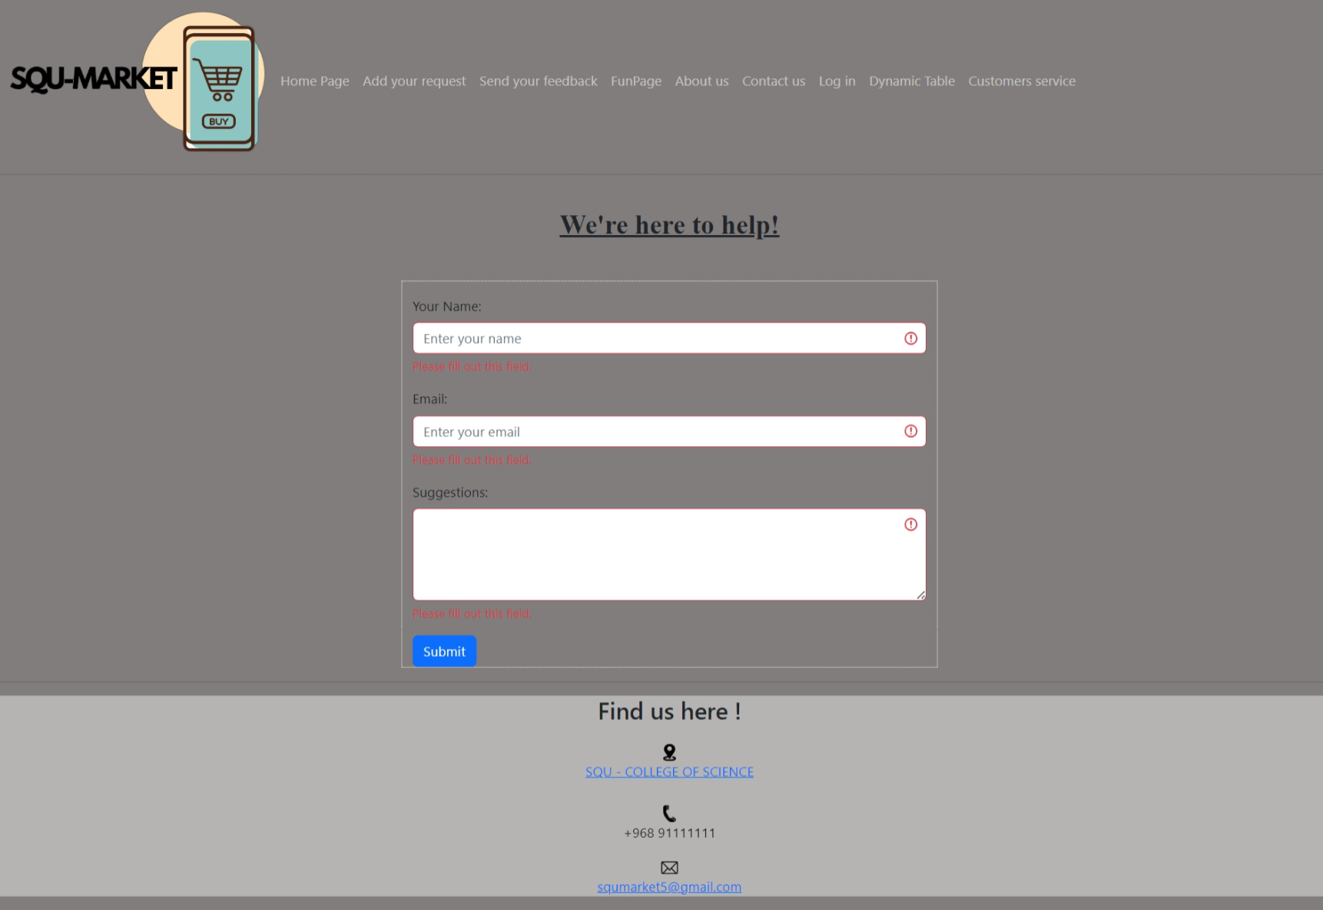

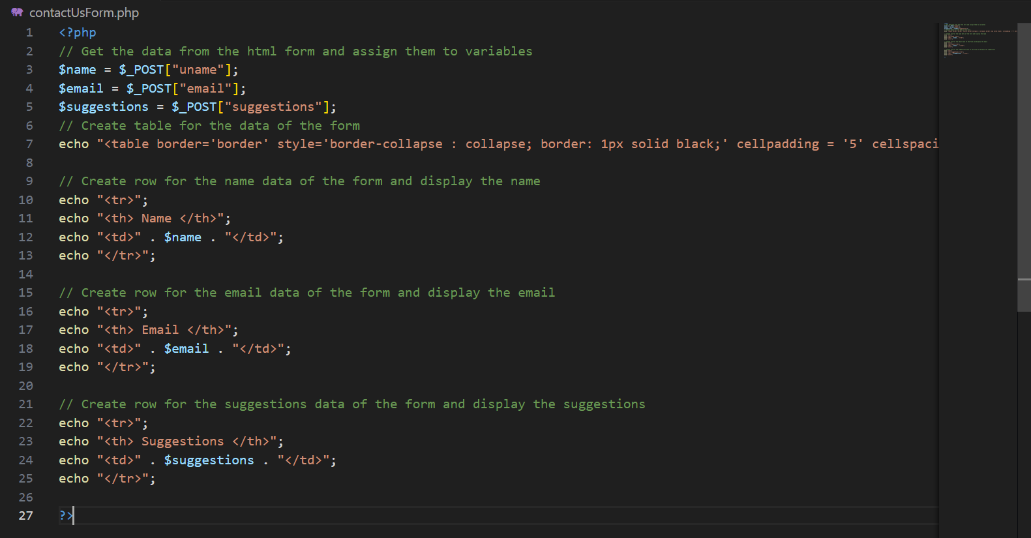

1. **Dynamic table page:**

1. **Add your request page:** A screenshot of a computer

   Description automatically generatedA screenshot of a computer program

   Description automatically generatedA screenshot of a computer code

   Description automatically generated
2. **Log in page:** 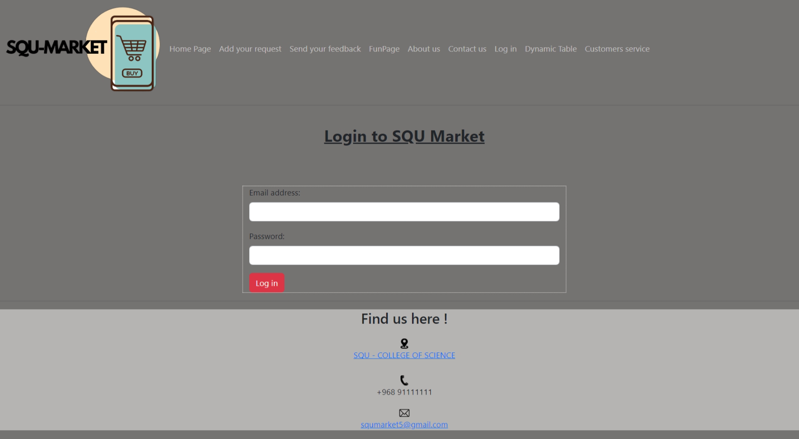A screenshot of a computer program

   Description automatically generated
3. **Search PHP:** Connected to request form that takes data from database(categories table) A screenshot of a computer program

   Description automatically generatedA screen shot of a computer

   Description automatically generatedA screenshot of a computer program

   Description automatically generatedA screen shot of a computer code

   Description automatically generatedA screen shot of a computer code

   Description automatically generatedA screenshot of a computer program

   Description automatically generatedA screen shot of a computer program

   Description automatically generatedA computer code on a black background

   Description automatically generated

# SQL code: A screen shot of a computer program Description automatically generatedA screen shot of a computer Description automatically generatedA screen shot of a computer Description automatically generatedA computer screen with text Description automatically generated

# Contribution Table:

|  |  |
| --- | --- |
| Ammar Abdullah Al Balushi 137497 | * Retrieve data from XHTML forms in previous parts of the project. |
| Ahmed Said Alghafri 129520 | * Data access using PHP web pages. |
| Mohammed Mattar Alshamsi 122711 | * Creating database using MySQL database. * Report and submission. |